12.2 Group Ⅶ
Name: ____________________ Class: ____________________ Due date: 3.13
1 .Ununseptium (atomic number 117) is a man- made element that is below astatine in Group VII of the Periodic Table.
What is the expected state of ununseptium at room temperature? （ ）
A a diatomic gas B a liquid C a monatomic gas D a solid

2. Element X is below iodine in the Periodic Table.
Which row correctly shows the physical state of element X at room temperature and its reactivity compared with that of iodine? （ ）
 | physical state of element X at room temperature | reactivity compared with that of iodine
A | gas | less reactive
B | solid | less reactive
C | gas | more reactive
D | solid | more reactive

3. Chlorine, bromine and iodine are elements in Group VII of the Periodic Table.
Which statement about these elements is not correct? （ ）
A The colour gets darker down the group.
B The density increases down the group.
C They are all gases at room temperature and pressure.
D They are all non- metals.

4. Element X is in Group VII of the Periodic Table.
It reacts with aqueous potassium bromide as shown.
$$X_{2}+2KBr→2KX+{Br}_{2}$$
Which statements about X are correct? （ ）
 | relative atomic mass | reactivity
A | greater than that of bromine | less reactive than bromine
B | greater than that of bromine | more reactive than bromine
C | less than that of bromine | less reactive than bromine
D | less than that of bromine | more reactive than bromine

5. Fluorine is at the top of Group VII in the Periodic Table.
Which row shows the properties of fluorine? （ ）
 | colour | state at room temperature | reaction with aqueous potassium iodide
A | brown | gas | no reaction
B | brown | liquid | iodine displaced
C | yellow | gas | iodine displaced
D | yellow | liquid | no reaction

6 .Which statement about the halogens and their compounds is correct? （ ）
A The colour of the element gets lighter going down Group VII.
B The elements get less dense going down Group VII.
C When chlorine is added to sodium iodide solution, iodine is formed.
D When iodine is added to sodium bromide solution, bromine is formed.

7. X is a Group I metal.
Y and Z are Group VII elements.
When X reacts with Y a salt is formed. A solution of this salt reacts with Z to form a different salt.
What are X, Y and Z? （ ）
 | X | Y | Z
A | K | Cl₂ | I₂
B | Li | Cl₂ | Br₂
C | Mg | Br₂ | Cl₂
D | Na | I₂ | Cl₂

8. Which pair of elements reacts together most violently? （ ）
A chlorine and lithium
B chlorine and potassium
C iodine and lithium
D iodine and potassium

9. The halogens are a collection of diatomic non- metals in Group VII.
Define the term diatomic. .........................................................................................[1]
(ii) What do the electron distributions of the halogens have in common?
..................................................................................................................................[1]
(iii) How do their electron distributions differ? ..........................................................[1]
Complete the table.
halogen | solid, liquid or gas at room temperature | colour
chlorine
bromine
iodine

10. The halogens are a group of non- metals in Group VII of the Periodic Table.
The reactivity of the halogens decreases down the group.
Describe an experiment which shows that chlorine is more reactive than iodine. Include an equation in your answer.
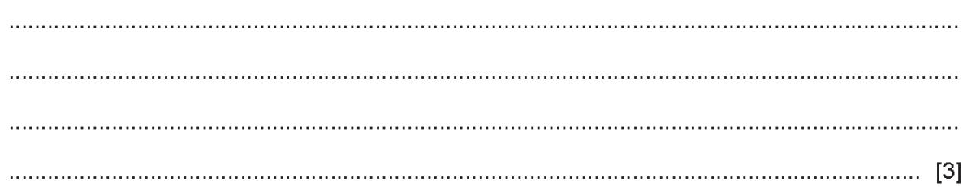
11. The halogens are the elements in Group VII of the Periodic Table.
Predict the physical state and colour of astatine at room temperature and pressure. physical state colour
.........................................................................................................................................................................................................................................................................[2]
When chlorine reacts with aqueous potassium bromide a displacement reaction occurs.
Describe the colour change of the solution. from to................................................. [2]
Write a chemical equation for this reaction...................................................... [2]
Reactions occur when some aqueous solutions of halogens are added to aqueous solutions of halides.
Use the key to complete the table to show the results of adding halogens to halides.
key $\sqrt{​}=$ reaction $x=$ no reaction
 |  | halides
 |  | KCl(aq) | KBr(aq) | KI(aq)
halogens | Cl₂(aq) |  | ✓
halogens | Br₂(aq)
halogens | I₂(aq)

